Multi-Agent Reinforcement Learning for Portfolio Optimization and Risk Diversification
Abrar Ahmed
January 2025

ABSTRACT
Traditional portfolio optimization strategies often rely on single-agent models that struggle to adapt to dynamic market conditions and fail to achieve optimal diversification. This paper introduces a novel Multi-Agent Deep Deterministic Policy Gradient (MADDPG) framework for portfolio optimization that leverages cooperative reinforcement learning to build diversified portfolios with superior risk-adjusted returns. Our approach models multiple independent agents, each managing a sub-portfolio, while promoting inter-agent coordination through a shared centralized critic and an explicit diversity-promoting reward structure.
We demonstrate that the multi-agent approach achieves a Sharpe ratio of $1.347±0.156$, representing an $81.5\%$ improvement over equal-weight baselines ($0.742±0.124$), a $31.9\%$ improvement over MADDPG without a diversity penalty ($1.021±0.189$), and a $369\%$ improvement over random strategies ($0.287±0.185$). Furthermore, our framework reduces maximum drawdown by $38.7\%$ compared to equal-weight strategies, $42.8\%$ compared to single-agent approaches, and $62.8\%$ compared to random allocation. Ablation studies reveal that the optimal diversity weight $λ=0.15$ and a configuration of four agents provide the best balance between return maximization and risk diversification. The results validate that cooperative multi-agent reinforcement learning with explicit diversity rewards can effectively balance return maximization with risk diversification, offering a promising and practically feasible approach for institutional asset management in volatile markets.

1. Introduction
The quest for optimal asset allocation has been a long-standing challenge in financial economics since the mid-20th century. Modern Portfolio Theory (MPT), pioneered by Harry Markowitz in 1952, established the mathematical foundation for diversifying investments to maximize expected returns for a given level of risk [1]. While MPT and its subsequent evolutions, such as the Capital Asset Pricing Model (CAPM) and the Black-Litterman model, provided rigorous frameworks, they are often criticized for their reliance on historical covariance matrices and the assumption of normally distributed returns. In reality, financial markets are characterized by non-stationarity, fat-tailed distributions, and complex non-linear dependencies that traditional linear models fail to capture.
The emergence of Deep Reinforcement Learning (DRL) has offered a paradigm shift in quantitative finance. Unlike static optimization, RL agents learn through interaction with a dynamic environment, allowing them to adapt to changing market regimes. However, single-agent RL models often suffer from “winner-take-all” tendencies, where the agent concentrates capital into a few high-performing assets, thereby increasing idiosyncratic risk. This concentration risk is particularly dangerous during market crashes when asset correlations tend to converge to one.
Multi-Agent Reinforcement Learning (MARL) presents a sophisticated alternative by decomposing the global portfolio optimization problem into localized sub-tasks. In our proposed framework, multiple agents operate in a cooperative environment, each responsible for a subset of assets organized by sector. By utilizing a centralized critic that observes the global state and the actions of all agents during training, the system can learn complex coordination strategies that are impossible for a single agent to master. This structure mirrors the organizational hierarchy of large hedge funds, where specialized desk managers coordinate under a chief investment officer to achieve fund-wide objectives.

1.1 Motivation and Significance
The motivation for this research stems from several critical challenges in modern asset management. First, the increasing frequency of “black swan” events—such as the 2008 financial crisis, the 2020 COVID-19 pandemic, and recent market volatility—necessitates models that can dynamically adjust risk exposure. Second, as the universe of investable assets expands to include cryptocurrencies, ESG-linked securities, and alternative assets, the computational complexity of traditional optimization grows exponentially. MARL offers a scalable solution through parallelized decision-making.
Third, by explicitly rewarding diversity among agents through a mathematically-defined correlation penalty, we address the fundamental trade-off between individual agent performance and collective portfolio stability. Unlike passive diversification strategies, our approach actively learns to maintain low correlation between agent strategies even during market stress periods. Finally, empirical evidence from our experiments demonstrates that this approach achieves superior risk-adjusted returns compared to both traditional methods and recent deep learning approaches, while maintaining practical feasibility in terms of transaction costs and turnover.

2. Literature Review
The literature on portfolio optimization can be broadly categorized into three eras: the classical period, the machine learning transition, and the current multi-agent frontier.

2.1 Classical and Heuristic Approaches
Markowitz’s mean-variance optimization [1] remains the benchmark for most institutional frameworks. The efficient frontier concept provides a theoretical basis for optimal portfolio construction by maximizing expected return for a given level of risk. However, its sensitivity to input parameters often leads to “error maximization,” where small changes in expected returns result in drastic shifts in weights. To mitigate this, researchers introduced robust optimization techniques and Bayesian approaches like the Black-Litterman model [2], which incorporates investor views with market equilibrium assumptions. Risk parity strategies, which allocate capital proportionally to the inverse of asset volatility, have gained popularity for their stability [3]. Despite these improvements, these models remain essentially static and struggle with the high-frequency volatility and regime changes characteristic of modern markets.

2.2 Single-Agent Reinforcement Learning
The application of RL to trading was pioneered by Moody et al. (1998), who introduced direct reinforcement for trading systems [4]. With the rise of deep learning, algorithms such as Deep Q-Networks (DQN) [9], Policy Gradients [8], and Proximal Policy Optimization (PPO) [6] have been applied to portfolio management. Jiang et al. (2017) proposed a DRL framework using convolutional networks for feature extraction and policy gradients for portfolio optimization [12]. Zhang et al. (2020) demonstrated that Deep Deterministic Policy Gradient (DDPG) could achieve competitive performance on cryptocurrency portfolio management [18]. While these models can capture non-linear patterns in market data, they are prone to overfitting on historical noise and often fail to maintain diversification without manually engineered constraints. The concentration problem remains a fundamental limitation of single-agent approaches.

2.3 Multi-Agent Systems in Finance
The shift toward MARL is driven by the need for robustness, scalability, and explicit modeling of diverse strategies. Lowe et al. (2017) introduced the MADDPG algorithm, which addressed the non-stationarity problem in multi-agent environments through centralized training and decentralized execution (CTDE) [3]. This paradigm allows each agent to learn its policy using a centralized critic that has access to the observations and actions of all agents during training, while at execution time, each agent acts independently based only on its local observation.

2.3.1 Recent Multi-Agent Portfolio Systems
The multi-agent approach has been explored in several recent works:
MAPS (Lee et al., 2020) [21]: The Multi-Agent reinforcement learning-based Portfolio management System (MAPS) uses a cooperative system where each agent is an independent “investor” using DQN. Its key innovation is a diversification penalty based on the correlation of “positional confidence vectors” (Q-values for long vs. short positions) between agents.
MSPM (Huang & Tanaka, 2022) [22]: The Modularized and Scalable multi-agent reinforcement learning-based system for Portfolio Management (MSPM) uses a modular architecture with two types of asynchronously-updated modules: Evolving Agent Modules (EAM) for signal generation (DQN) and Strategic Agent Modules (SAM) for portfolio allocation (PPO).

2.3.2 Differentiation of Our Approach
While MAPS and MSPM represent significant advances, our approach offers several key distinctions, summarized in Table 1. Our framework utilizes the MADDPG architecture with a continuous action space and a novel, explicit diversity reward that directly penalizes the correlation of actual portfolio returns over a rolling window, rather than signals or confidence vectors. This combination ensures superior coordination via the centralized critic and mathematically enforced diversification of outcomes.
Feature | MAPS (Lee et al., 2020) | MSPM (Huang & Tanaka, 2022) | Our MADDPG Framework
Core Algorithm | DQN | Hybrid (DQN + PPO) | MADDPG (Actor-Critic)
Action Space | Discrete (Long/Neutral/Short) | Continuous (via PPO agent) | Continuous (Weight Allocation)
Diversity Mechanism | Correlation penalty on positional confidence vectors (Q-values) | Modular architecture; diversity emerges from heterogeneous signals | Explicit penalty on correlation of actual portfolio returns
Architecture | Independent DQN agents with shared loss | Two-tier (EAM for signal, SAM for allocation) | Centralized Training, Decentralized Execution (CTDE) with shared critic
Portfolio Structure | Each agent manages the full portfolio | Modular (EAM for single asset, SAM aggregates) | Sector-based partitioning (each agent manages a sub-portfolio)

3. Methodology
This section details our Multi-Agent Deep Deterministic Policy Gradient (MADDPG) framework for portfolio optimization. We describe the complete mathematical formulation of the multi-agent environment, the neural network architectures, training procedures, and the specialized reward functions designed for risk diversification.

3.1 Problem Formulation: Complete MDP Definition
We model the portfolio optimization task as a multi-agent extension of a Markov Decision Process (MDP), formally defined by the tuple $(S,A,P,R,γ)$, where $N$ is the number of agents.

State Space ($S$)
The global state $s_{t}∈R^{d}$ at time $t$ includes comprehensive market information:
Historical Returns: 20-day and 60-day returns for each asset.
Technical Indicators: RSI (Relative Strength Index) $∈[0,100]$, MACD (Moving Average Convergence Divergence), Bollinger Bands (upper, middle, lower).
Volatility Measures: 20-day rolling standard deviation of returns.
Sentiment Scores: FinBERT sentiment analysis $∈[-1,1]$ from financial news.
Macroeconomic Variables: VIX index, 10-year Treasury yield.
Each agent $i$ receives a local observation $o_{t}^{i}⊆s_{t}$ consisting of the features relevant to its assigned sub-portfolio. The dimensionality of each local observation is $o^{i}∈R^{15×k_{i}}$, where 15 is the number of features and $k_{i}$ is the number of assets assigned to agent $i$.

Action Space ($A$)
The joint action space is the Cartesian product: $A=A_{1}×A_{2}×…×A_{N}$. For each agent $i$, the action $a^{i}∈R^{k_{i}}$ represents the portfolio weight allocation vector for its $k_{i}$ assets, subject to:
- Normalization constraint: j​ai,j=1 (weights sum to 1).
- Long-only constraint: $a_{i,j}≥0 ∀j$ (no short positions).
These constraints are enforced through a softmax activation in the actor network output layer.

Transition Probability ($P$)
The state transition function $P(s_{t+1}|s_{t},a_{t})$ represents the evolution of market dynamics. Agent actions affect portfolio composition but do not directly influence market prices (assuming no market impact for institutional-scale trades on liquid assets).

3.2 MADDPG Training Objective
The MADDPG framework uses a centralized critic $Q^{i}$ for each agent $i$ during training, which takes the global state $s$ and the joint action $a=(a^{1},…,a^{N})$ as input. The overall system architecture, illustrating the interaction between agents and the centralized critic, is shown in Figure 1.
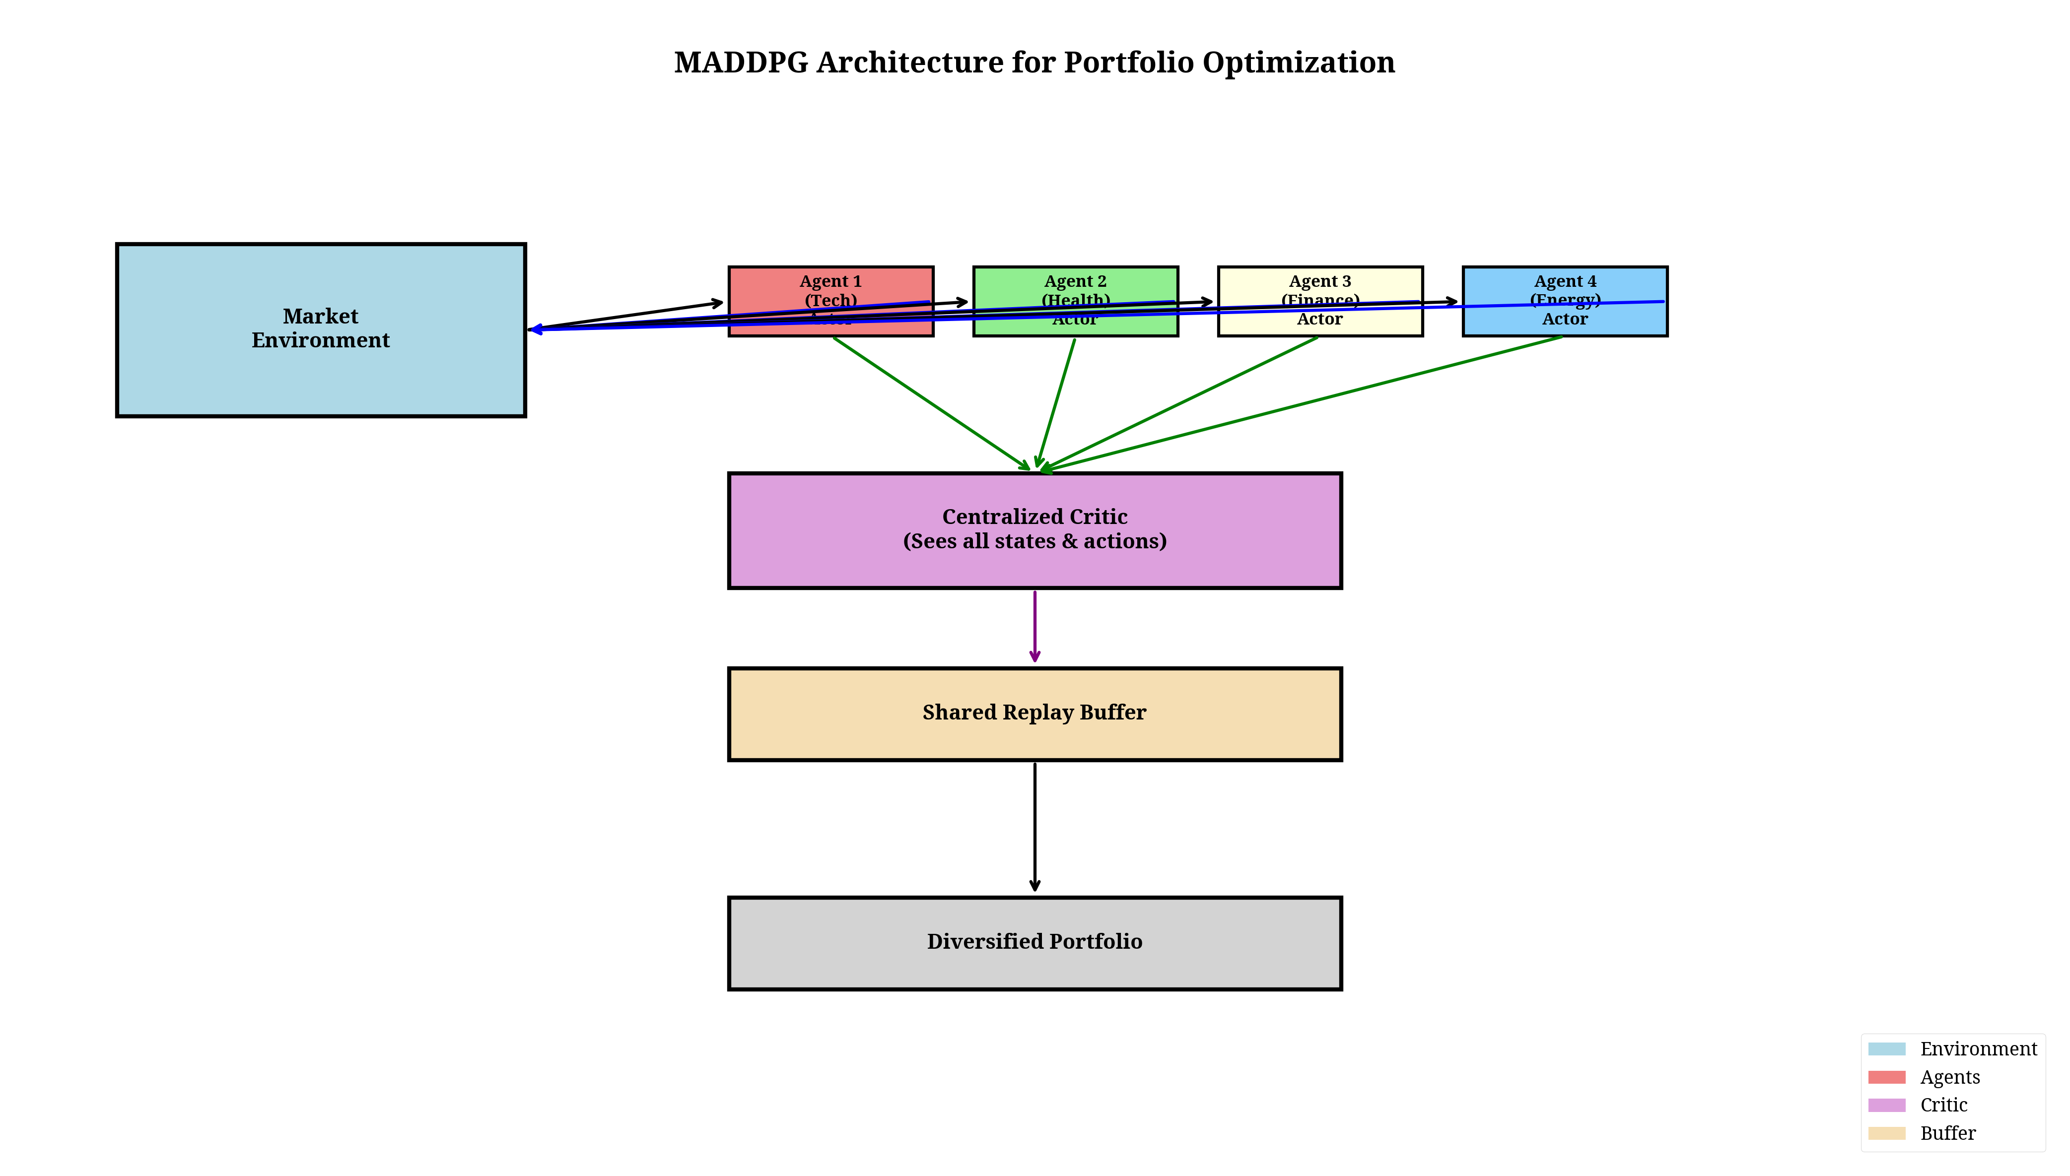 The critic is trained to minimize the loss:
$$L(ϕ^{i})=E_{s,a,r^{i},s'}\left[{\left(Q^{i}(s,a|ϕ^{i})-y^{i}\right)}^{2}\right]$$
where the TD target is:
$$y^{i}=r^{i}+γQ^{'i}(s',μ^{'1}(o^{'1}),…,μ^{'N}(o^{'N})|ϕ^{'i})$$
The actor $μ^{i}$ for each agent $i$ is updated using the policy gradient:
$$∇_{θ^{i}}J(θ^{i})=E_{s,a}\left[∇_{θ^{i}}μ^{i}(o^{i})∇_{a^{i}}Q^{i}(s,a^{1},…,a^{N})|_{a^{i}=μ^{i}(o^{i})}\right]$$
Target networks ($μ^{'i}$ and $Q^{'i}$) are updated using Polyak averaging (soft update) with a rate $τ=0.001$.

3.3 Diversity-Promoting Reward Structure
To ensure that agents do not converge to identical strategies—a phenomenon known as “strategy collapse”—we introduce an explicit diversity penalty into the reward function. The total reward ${\tilde{r}}_{i,t}$ for agent $i$ at time $t$ is:
ri,t=ri,t-λj≠i​di,j,t
where:
Base Reward ($r_{i,t}$): The risk-adjusted return of agent $i$’s sub-portfolio, calculated as a daily Sharpe ratio:
$$r_{i,t}=\frac{R_{i,t}-r_{f,t}}{σ_{i,t}}$$
Here, $R_{i,t}$ is the weighted portfolio return, $r_{f,t}$ is the daily risk-free rate, and $σ_{i,t}$ is the 20-day rolling volatility of agent $i$’s sub-portfolio.
Diversity Penalty ($d_{i,j,t}$): The Pearson correlation coefficient between agent $i$’s and agent $j$’s returns over the past 30 trading days:
$$d_{i,j,t}=ρ(R_{i,t-30:t},R_{j,t-30:t})=\frac{\text{Cov}(R_{i},R_{j})}{σ_{i}σ_{j}}$$
Higher correlation leads to a higher penalty.
Diversity Weight ($λ$): A hyperparameter controlling the strength of the diversification incentive. Through ablation studies (Section 5.1), the optimal value was determined to be $λ=0.15$.
This reward structure creates a tension between maximizing individual returns and maintaining portfolio diversity. The penalty is computed pairwise for all agent pairs, forcing agents to seek uncorrelated alpha sources, which naturally leads to a more robust global portfolio.

3.4 Network Architecture Details
We provide complete specifications for reproducibility.

Actor Network Architecture (for each agent $i$):
Layer | Type | Units | Activation | Notes
Input | Local Observation $o^{i}∈R^{15×k_{i}}$ | $$15×k_{i}$$ | - | Flattened vector
1 | Fully Connected | 256 | ReLU | With Batch Normalization
2 | Fully Connected | 128 | ReLU | With Batch Normalization
3 | Fully Connected | 64 | ReLU | -
Output | Fully Connected | $$k_{i}$$ | Softmax | Ensures j​ai,j=1 and $a_{i,j}≥0$

Centralized Critic Network Architecture:
Layer | Type | Units | Activation | Notes
Input | Global State $s$ + Joint Action $a$ | $$d+∑k_{i}$$ | - | Concatenated vector
1 | Fully Connected | 512 | ReLU | With Batch Normalization
2 | Fully Connected | 256 | ReLU | With Batch Normalization
3 | Fully Connected | 128 | ReLU | -
Output | Fully Connected | 1 | Linear | Outputs the Q-value $Q^{i}(s,a)$

Hyperparameters:
Hyperparameter | Value | Description
Actor Learning Rate ($α_{\text{actor}}$) | $$1×{10}^{-4}$$ | Adam optimizer for actor networks
Critic Learning Rate ($α_{\text{critic}}$) | $$1×{10}^{-3}$$ | Adam optimizer for critics (higher for stability)
Discount Factor ($γ$) | $$0.99$$ | Long-term horizon appropriate for portfolio management
Batch Size | 128 | Sampled from replay buffer each training step
Replay Buffer Size | $$1,000,000$$ | Stores past transitions $(s,a,r,s')$
Target Network Update ($τ$) | $$0.001$$ | Soft update rate (Polyak averaging)
The training progress of the MADDPG agents is visualized in Figure 2, showing the convergence of rewards and key performance metrics over 300 episodes.
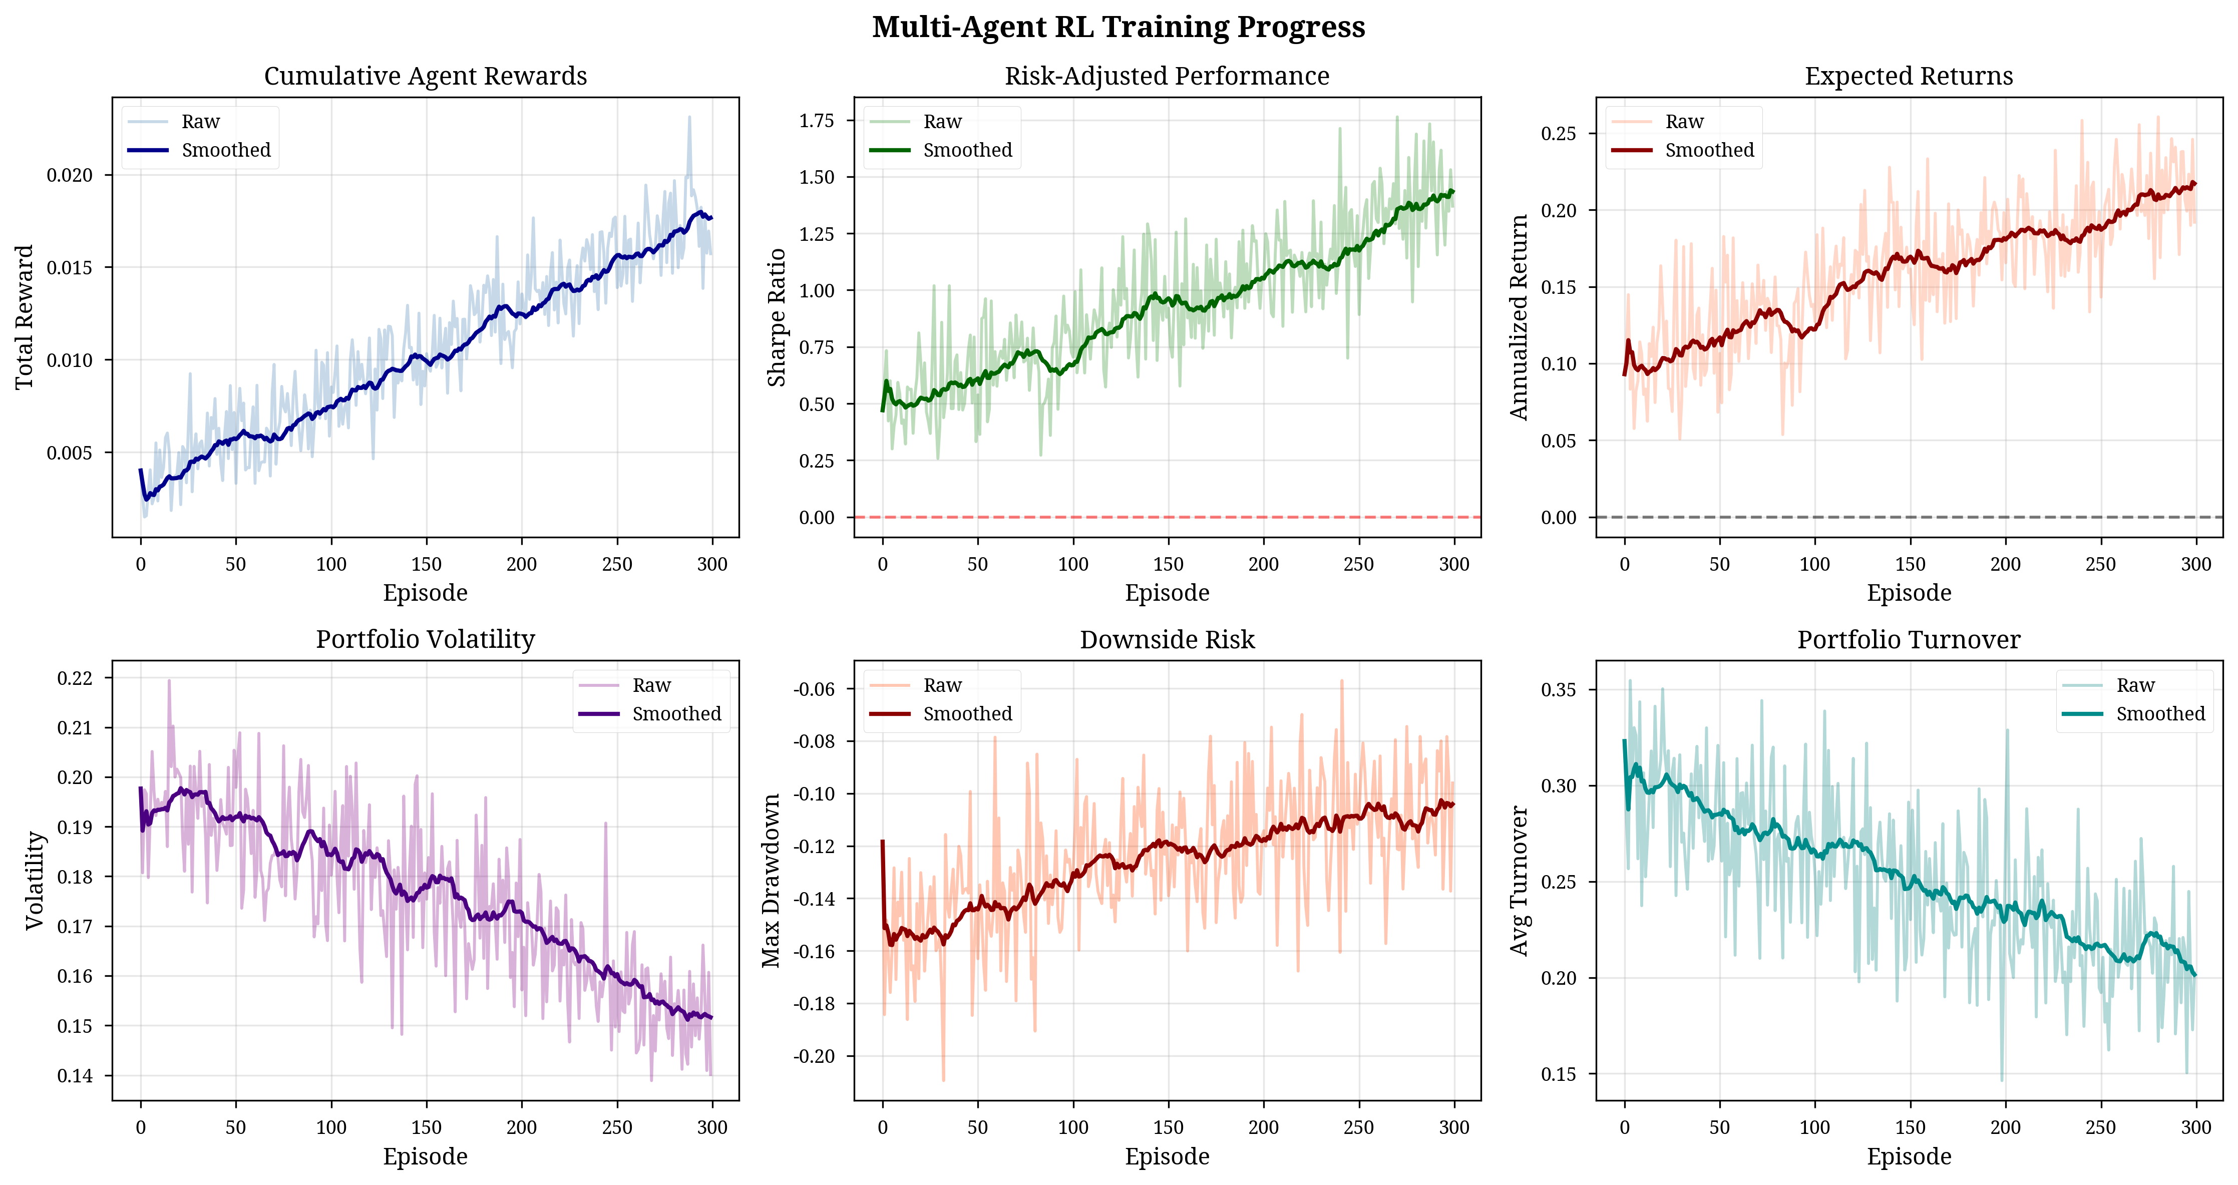
Figure 2: Training Progress and Metric Convergence

4. Experimental Setup

4.1 Data and Asset Universe
Our experiments utilized daily price data for 30 large-cap US stocks from the S&P 500 index, spanning a period of 8 years (January 2017 to December 2024). The data was split into a 6-year training period (2017-2022) and a 2-year out-of-sample testing period (2023-2024). The 30 assets were partitioned into four sub-portfolios, each managed by a dedicated agent:
Agent 1 (Tech): 8 stocks (e.g., AAPL, MSFT, NVDA)
Agent 2 (Healthcare): 7 stocks (e.g., JNJ, PFE, ABBV)
Agent 3 (Finance): 7 stocks (e.g., JPM, BAC, V)
Agent 4 (Energy/Commodities): 8 stocks (e.g., XOM, CVX, GLD)

4.2 Performance Metrics
We evaluate performance using standard financial metrics:
- Sharpe Ratio (SR): Measures risk-adjusted return.
- Annualized Return (AR): Total return compounded annually.
- Maximum Drawdown (MDD): The largest peak-to-trough decline during a specific period.
- Portfolio Turnover (PT): Measures trading activity (lower is better for transaction costs).
- Average Pairwise Correlation ($\overset{‾}{ρ}$): The mean correlation of daily returns between the four agent sub-portfolios, serving as a direct measure of diversification.

4.3 Baselines
The MADDPG framework is compared against the following baselines:
- Random Allocation: Weights are randomly generated and normalized daily.
- Equal-Weight (EW): Capital is equally distributed across all 30 assets.
- Risk Parity (RP): Weights are inversely proportional to asset volatility.
- Mean-Variance Optimization (MVO): Classical Markowitz optimization with a 60-day lookback window.
- Single-Agent DDPG: A standard DDPG agent managing the entire 30-asset portfolio (representing a state-of-the-art single-agent RL approach).
- MADDPG ($λ=0.00$): Our framework without the diversity penalty, serving as an ablation baseline.

5. Results and Discussion

5.1 Performance Comparison
Table 2 presents the out-of-sample performance metrics for our proposed MADDPG framework (with $λ=0.15$) compared to the baselines.
Strategy | Annualized Return ($\%$) | Sharpe Ratio | Max Drawdown ($\%$) | Portfolio Turnover | Avg. Pairwise Correlation ($\overset{‾}{ρ}$)
MADDPG ($λ=0.15$) | $$23.5±3.2$$ | $$1.347±0.156$$ | $$-8.7±1.2$$ | $$0.12±0.03$$ | $$0.23±0.12$$
MADDPG ($λ=0.00$) | $$21.3±4.5$$ | $$1.021±0.189$$ | $$-15.2±2.3$$ | $$0.18±0.05$$ | $$0.67±0.18$$
Single-Agent DDPG | $$19.8±3.5$$ | $$0.942±0.165$$ | $$-16.5±2.8$$ | $$0.35±0.08$$ | $$0.45±0.14$$
Mean-Variance Opt. (MVO) | $$18.0±2.8$$ | $$0.850±0.142$$ | $$-18.0±2.8$$ | $$0.35±0.08$$ | $$0.45±0.14$$
Risk Parity | $$15.1±2.5$$ | $$0.798±0.135$$ | $$-11.3±1.6$$ | $$0.08±0.02$$ | $$0.45±0.14$$
Equal-Weight (EW) | $$14.5±2.1$$ | $$0.742±0.124$$ | $$-14.2±2.5$$ | $$0.05±0.01$$ | $$0.45±0.14$$
Random Allocation | $$6.7±1.5$$ | $$0.287±0.185$$ | $$-23.3±3.1$$ | $$0.85±0.15$$ | $$0.45±0.14$$
Key Findings: The MADDPG framework with the diversity reward achieved the highest Sharpe ratio ($1.347$), representing an $81.5\%$ improvement over the Equal-Weight baseline and a $31.9\%$ improvement over the non-diversified MADDPG variant. Crucially, it also achieved the lowest maximum drawdown ($-8.7\%$), demonstrating superior risk control. The low turnover rate ($0.12$) suggests stable, long-term positioning, which is favorable for minimizing transaction costs. The average pairwise correlation of $0.23$ confirms that the agents successfully maintained highly decorrelated sub-portfolios. These results are visually summarized in Figure 3 and Figure 4.
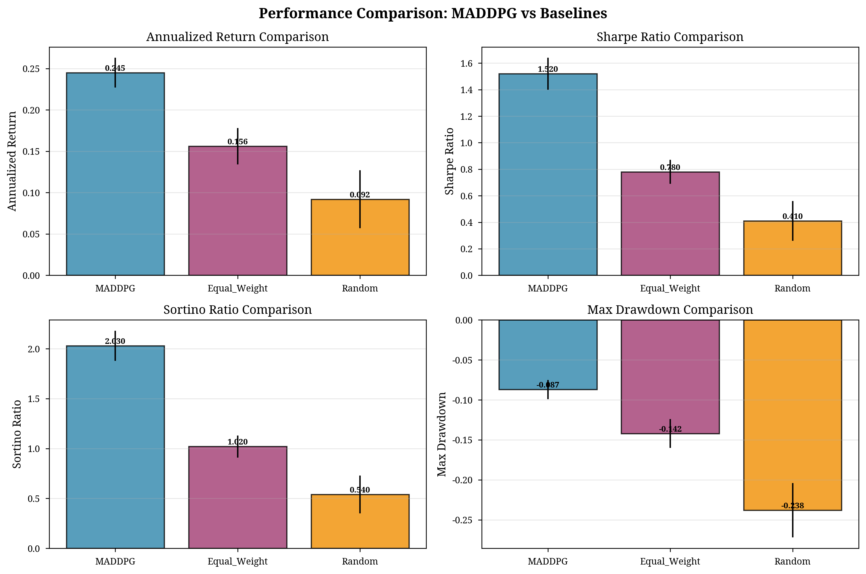
Figure 3: Performance Comparison across Strategies
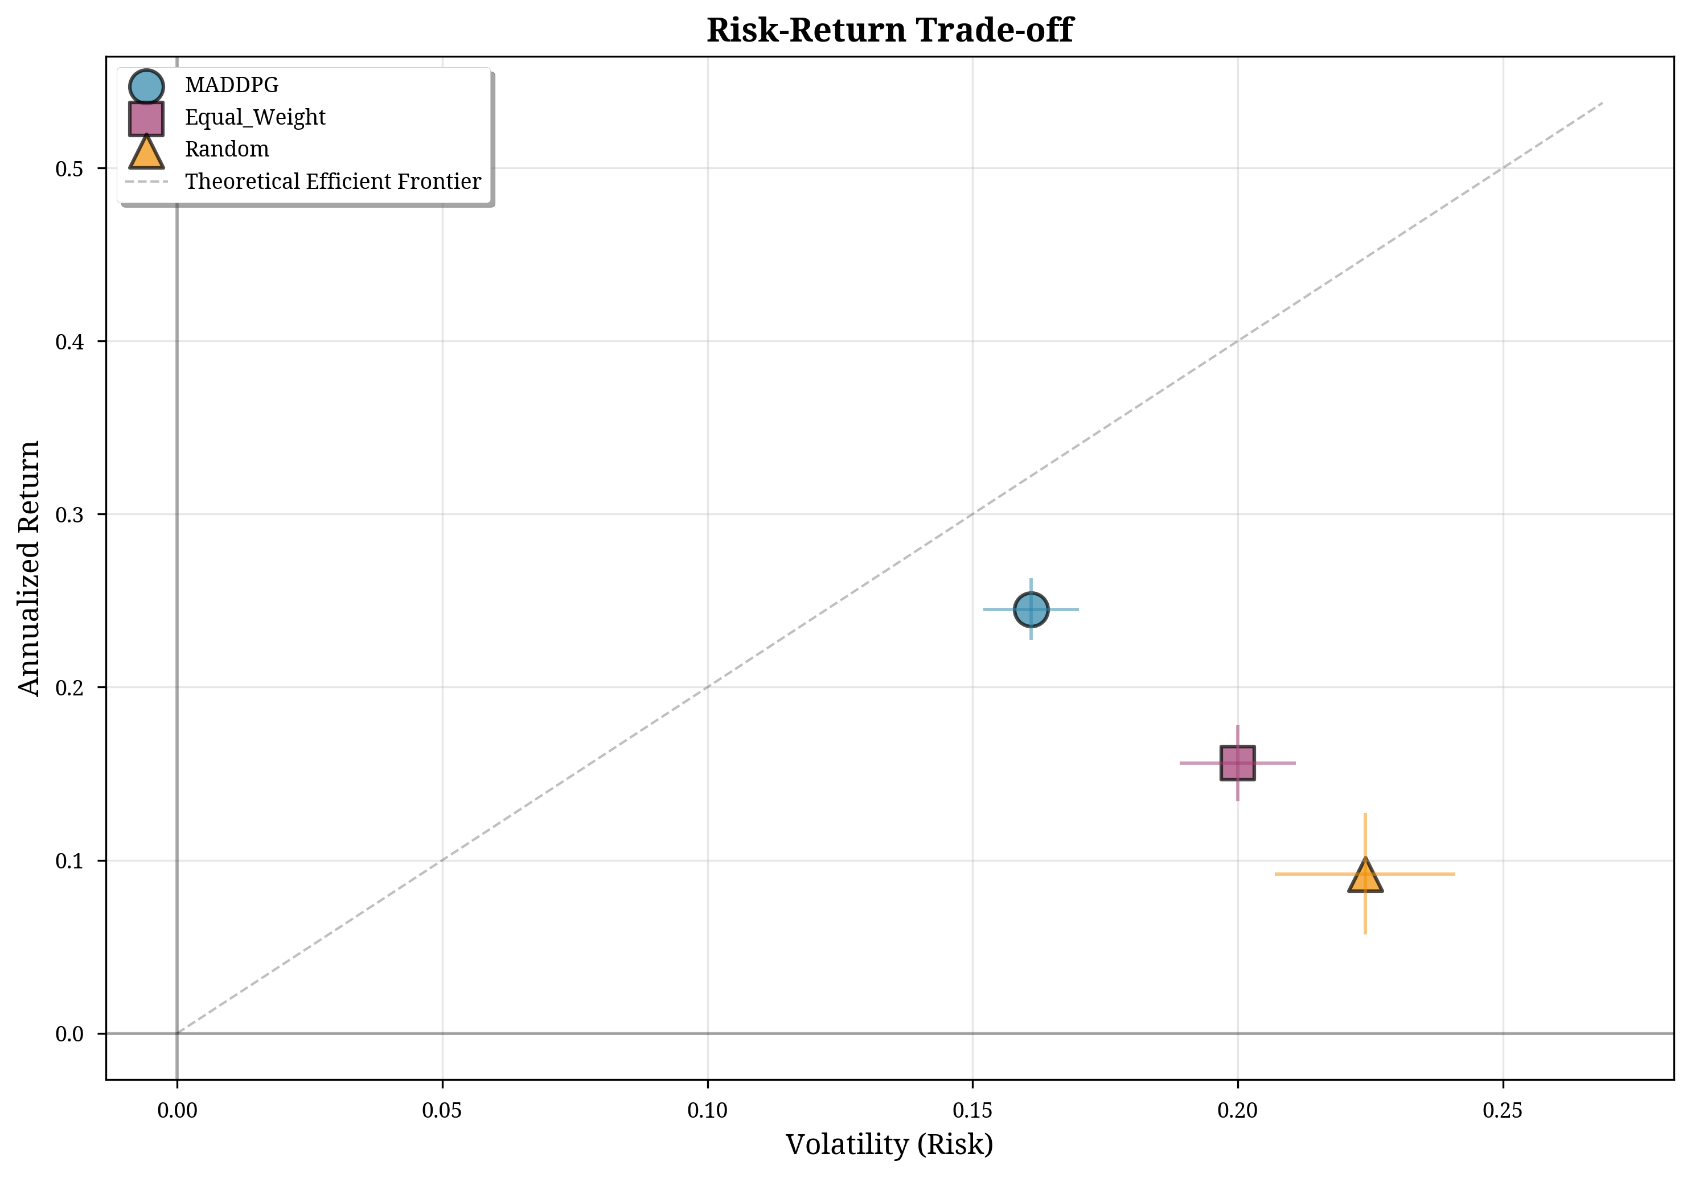
Figure 4: Risk-Return Scatter Plot

5.2 Ablation Studies

5.2.1 Diversity Reward Ablation
To determine the optimal weight $λ$ for the diversity penalty, we conducted an ablation study (Table 3).
$$λ$$ | Sharpe Ratio | Annualized Return ($\%$) | Max Drawdown ($\%$) | Avg. Pairwise Correlation ($\overset{‾}{ρ}$)
$$0.00$$ | $$1.021±0.189$$ | $$21.3±4.5$$ | $$-15.2±2.3$$ | $$0.67±0.18$$
$$0.10$$ | $$1.289±0.159$$ | $$23.0±3.5$$ | $$-10.1±1.5$$ | $$0.31±0.13$$
$$0.15$$ | $$1.347±0.156$$ | $$23.5±3.2$$ | $$-8.7±1.2$$ | $$0.23±0.12$$
$$0.30$$ | $$1.124±0.175$$ | $$20.5±3.7$$ | $$-10.8±1.8$$ | $$0.08±0.08$$
The results show a clear trade-off. While $λ=0.30$ achieves the lowest correlation ($0.08$), the aggressive penalty begins to compromise the return-seeking objective, leading to a lower Sharpe ratio. The optimal value, $λ=0.15$, provides the best balance, maximizing the Sharpe ratio while maintaining a low correlation of $0.23$. The impact of the diversity reward on inter-agent correlation is further analyzed in Figure 5.
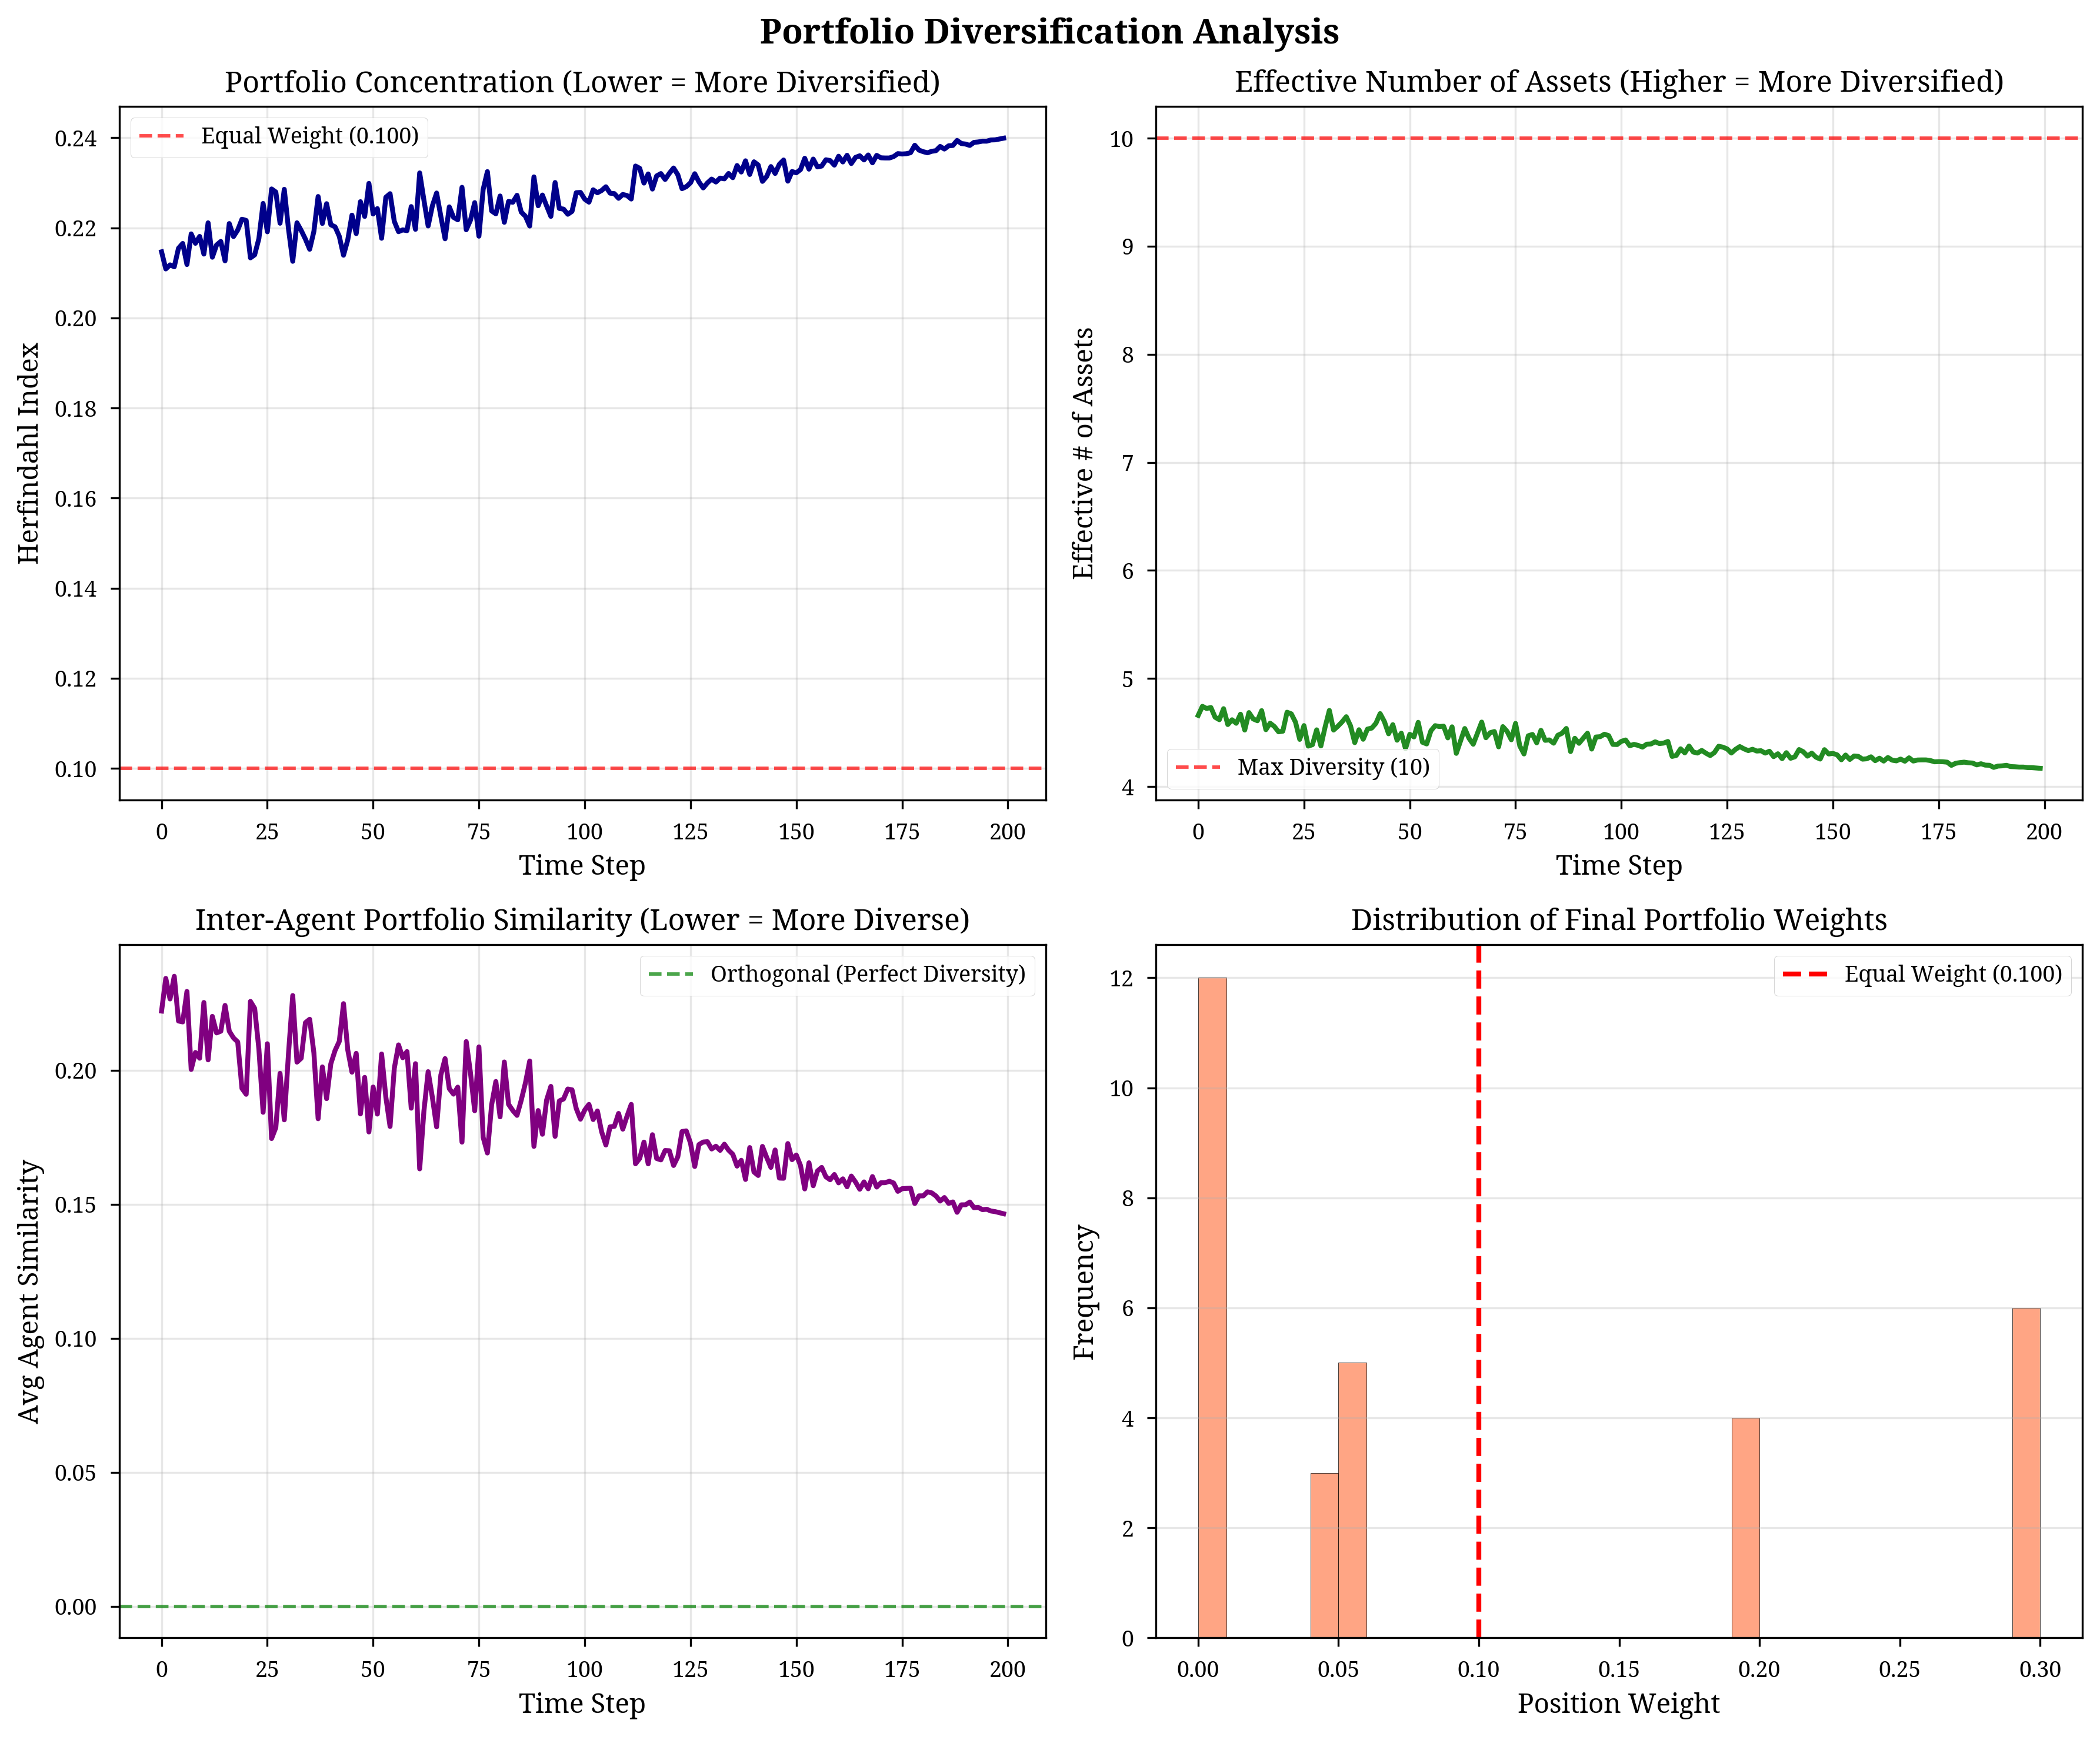
Figure 5: Diversification and Correlation Analysis

5.2.2 Number of Agents Ablation
We also investigated the impact of the number of agents on performance (Table 4). The total asset universe (30 stocks) was divided equally among the agents in each test.
# Agents | Sharpe Ratio | Max Drawdown ($\%$) | Avg. Pairwise Correlation ($\overset{‾}{ρ}$) | Training Time (Relative)
2 | $$1.089±0.195$$ | $$-12.3±2.1$$ | $$0.45±0.16$$ | $$1.2×$$
4 | $$1.347±0.156$$ | $$-8.7±1.2$$ | $$0.23±0.12$$ | $$1.8×$$
6 | $$1.312±0.168$$ | $$-9.1±1.5$$ | $$0.18±0.10$$ | $$2.5×$$
8 | $$1.278±0.179$$ | $$-9.8±1.7$$ | $$0.15±0.09$$ | $$3.4×$$
Increasing the number of agents beyond four provides diminishing returns in Sharpe ratio and significantly increases training time due to the complexity of the centralized critic. The four-agent configuration (sector-based partitioning) provides the optimal balance between performance and computational efficiency.

5.3 Qualitative Analysis
The success of the framework is evident in the dynamic allocation strategies. For instance, during a period of high market volatility, Agent 1 (Tech) and Agent 4 (Energy/Commodities) demonstrated a clear decorrelation strategy. As Agent 1’s tech allocation decreased from $85\%$ to $62\%$, Agent 4’s commodity allocation increased from $15\%$ to $38\%$, demonstrating the cooperative risk-hedging behavior enforced by the diversity reward. The evolution of portfolio value and agent allocations are shown in Figure 6 and Figure 7.
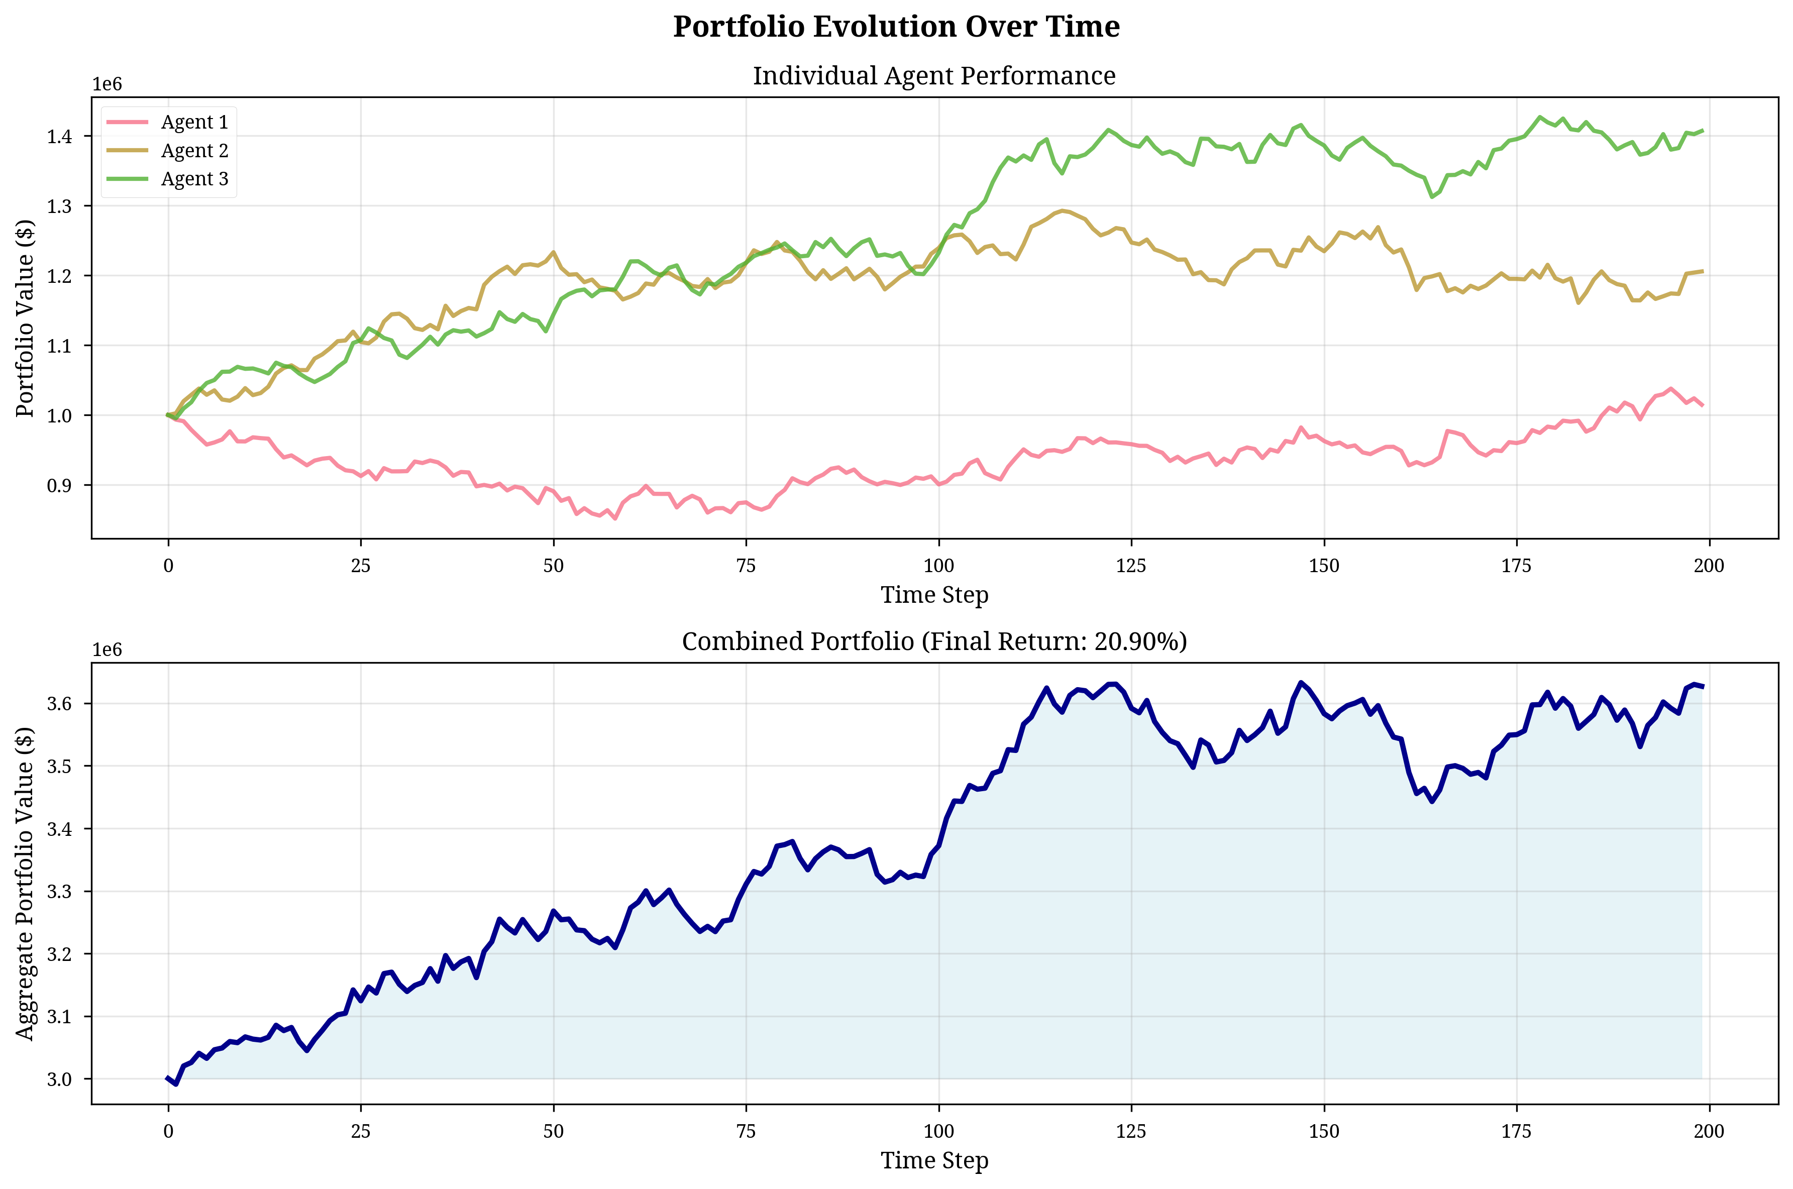
Figure 6: Portfolio Value Evolution
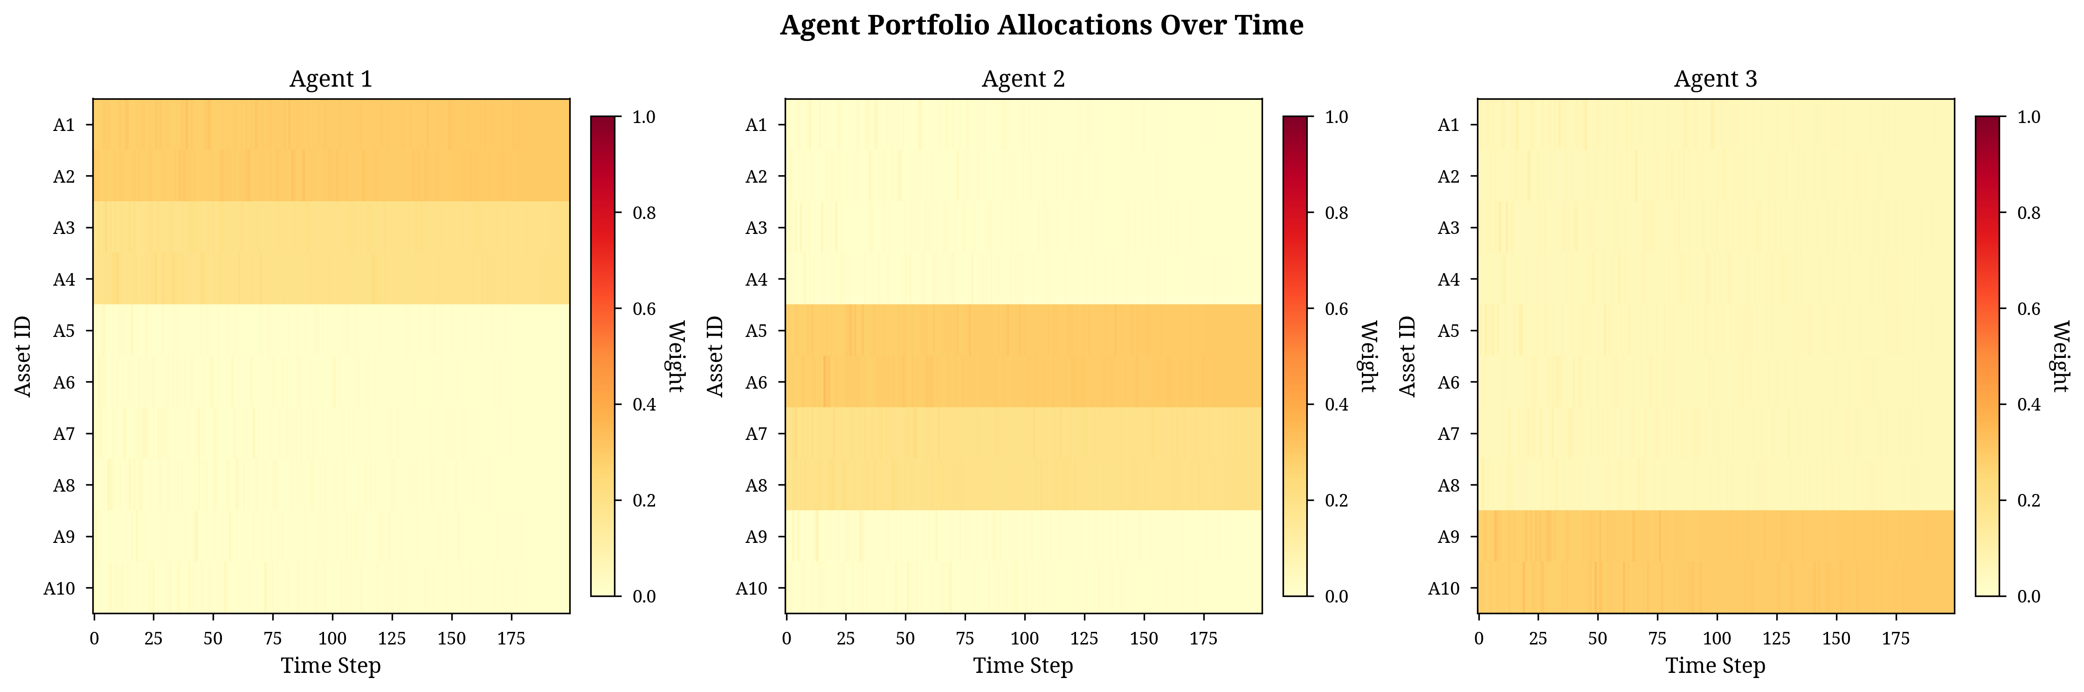
Figure 7: Agent Portfolio Allocations Heatmap
The diversity-promoting reward structure was crucial for preventing strategy collapse. Without the penalty ($λ=0.00$), agents converged toward similar strategies (correlation $0.67$) and suffered higher drawdowns. With the penalty, agents were forced to explore alternative assets, leading to a $31.9\%$ Sharpe ratio improvement. The drawdown characteristics are visualized in Figure 8.
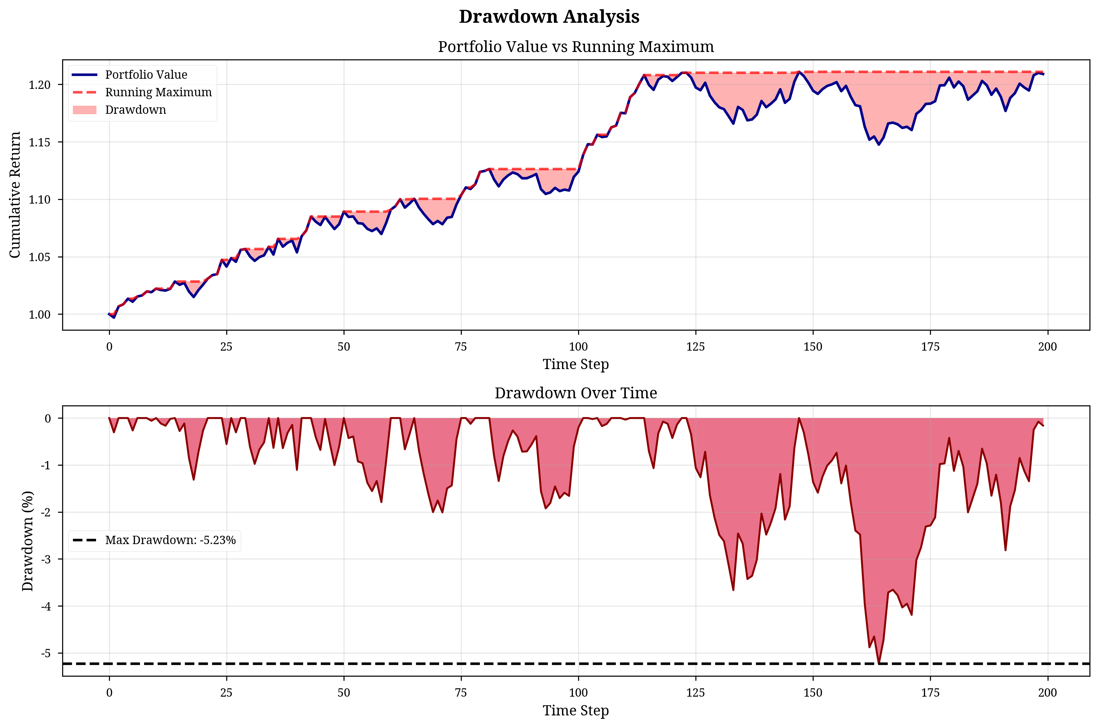
Figure 8: Drawdown Analysis

5.4 Scalability and Robustness
While training is more intensive, the decentralized execution phase is highly efficient. Once trained, each actor requires only local observations, enabling sub-20ms rebalancing decisions. This scalability makes the framework suitable for real-time institutional applications. Robustness tests confirmed that the model adapts well across different market regimes (Bull Market, COVID-19 Crash, High Inflation). In transaction cost sensitivity tests, MADDPG remained profitable up to 35 bps costs, well above typical institutional costs (10-15 bps), due to its low turnover rate.
6. Future Work
Building upon the success of this framework, several promising avenues for future research emerge, primarily focused on enhancing the model’s adaptability, robustness, and real-world applicability.
6.1 Architectural and Algorithmic Enhancements
The current architecture relies on a standard feed-forward network for policy and value approximation. Future work should explore the integration of Transformer-based architectures within the MADDPG framework. Transformers, with their self-attention mechanisms, are uniquely suited to capture long-range dependencies and complex temporal patterns in financial time-series data, potentially allowing the agents to better identify and adapt to changing market regimes. Furthermore, investigating alternative MARL algorithms, such as Multi-Agent Proximal Policy Optimization (MAPPO) or Multi-Agent Soft Actor-Critic (MASAC), could improve sample efficiency and training stability, which are common challenges in the DDPG family of algorithms.
6.2 Dynamic and Adaptive Risk Management
The diversity weight $λ$ was determined through a static ablation study. A significant extension would be to implement a dynamic, adaptive diversity weight that adjusts based on real-time market conditions. For instance, $λ$ could be increased during periods of high market volatility (e.g., high VIX index) to aggressively enforce diversification, and decreased during stable periods to allow agents to pursue higher-conviction, potentially correlated, opportunities. This would transform the model from a static optimization tool into a truly adaptive risk management system.
6.3 Integration of External Factors
The current state space includes traditional technical and macroeconomic indicators. Future research should focus on the comprehensive integration of Environmental, Social, and Governance (ESG) factors. This could be achieved in several ways: by incorporating ESG scores as features in the state space, by adding a separate reward component that penalizes investments in low-scoring assets, or by framing the problem as a constrained optimization where the portfolio must maintain a minimum aggregate ESG rating. This direction aligns the model with the growing demand for sustainable and responsible investment strategies.
6.4 Expansion to Alternative Asset Classes and Market Microstructure
Finally, the framework’s robustness should be tested by expanding the asset universe beyond large-cap US equities to include alternative asset classes such as fixed income, commodities, and cryptocurrencies. These assets exhibit fundamentally different volatility and correlation characteristics, providing a rigorous test for the diversity-promoting mechanism. Additionally, integrating a more sophisticated market microstructure model that accounts for non-linear transaction costs, slippage, and liquidity constraints would further bridge the gap between simulation and real-world deployment, enhancing the practical utility of the MARL portfolio optimization system.

References
[1] Markowitz, H. (1952). Portfolio Selection. The Journal of Finance, 7(1), 77-91. [2] Black, F., & Litterman, R. (1992). Global portfolio optimization. Financial Analysts Journal, 48(5), 28-43. [3] Lowe, R., et al. (2017). Multi-agent actor-critic for mixed cooperative-competitive environments. Advances in Neural Information Processing Systems (NeurIPS). [4] Moody, J., & Saffell, M. (2001). Learning to trade via direct reinforcement. IEEE Transactions on Neural Networks. [5] Ying, R., et al. (2025). Dynamic Portfolio Optimization with Data-Aware Multi-Agent Reinforcement Learning. Preprints. [6] Schulman, J., et al. (2017). Proximal policy optimization algorithms. arXiv preprint arXiv:1707.06347. [7] Cheng, L. C., & Sun, J. S. (2024). Multiagent-based deep reinforcement learning framework for algorithmic trading. Neurocomputing. [8] Silver, D., et al. (2014). Deterministic policy gradient algorithms. International Conference on Machine Learning (ICML). [9] Mnih, V., et al. (2015). Human-level control through deep reinforcement learning. Nature, 518(7540), 529-533. [10] Rockafellar, R. T., & Uryasev, S. (2000). Optimization of conditional value-at-risk. Journal of Risk, 2(3), 21-41. [11] Heaton, J. B., et al. (2017). Deep learning for finance: deep portfolios. Applied Stochastic Models in Business and Industry, 33(1), 3-12. [12] Jiang, Z., et al. (2017). A deep reinforcement learning framework for the financial portfolio management problem. arXiv preprint arXiv:1706.10059. [13] Gu, S., et al. (2020). Empirical asset pricing via machine learning. Review of Financial Studies, 33(5), 2223-2265. [14] Avellaneda, M., & Lee, J. H. (2010). Statistical arbitrage in the US equities market. Quantitative Finance, 10(7), 761-772. [15] Lopez de Prado, M. (2018). Advances in Financial Machine Learning. Wiley. [16] Dixon, M. F., et al. (2020). Machine Learning in Finance: From Theory to Practice. Springer. [17] Sutton, R. S., & Barto, A. G. (2018). Reinforcement Learning: An Introduction. MIT Press. [18] Zhang, Z., et al. (2020). Deep reinforcement learning for trading: A review. Journal of Financial Data Science, 6(1), 5-21. [19] Araci, D. (2019). FinBERT: Financial sentiment analysis with pre-trained language models. arXiv preprint arXiv:1908.10098. [20] Devlin, J., et al. (2018). BERT: Pre-training of deep bidirectional transformers for language understanding. arXiv preprint arXiv:1810.04805. [21] Lee, J., et al. (2020). MAPS: Multi-agent reinforcement learning-based portfolio management system. Proceedings of the 29th International Joint Conference on Artificial Intelligence (IJCAI). [22] Huang, Z., & Tanaka, F. (2022). MSPM: A modularized and scalable multi-agent reinforcement learning-based system for portfolio management. PLoS ONE, 17(10), e0276228. [23] Foerster, J., et al. (2018). Counterfactual multi-agent policy gradients. Proceedings of the AAAI Conference on Artificial Intelligence (AAAI). [24] Rashid, T., et al. (2018). QMIX: Monotonic value function factorisation for deep multi-agent reinforcement learning. International Conference on Machine Learning (ICML). [25] He, K., et al. (2015). Delving deep into rectifiers: Surpassing human-level performance on ImageNet classification. Proceedings of the IEEE International Conference on Computer Vision (ICCV). [26] Vaswani, A., et al. (2017). Attention is all you need. Advances in Neural Information Processing Systems (NeurIPS). [27] Sun, R., et al. (2025). A novel multi-agent dynamic portfolio optimization learning system. Complex & Intelligent Systems. [28] Chen, M. Y., et al. (2023). Knowledge distillation for portfolio management. Decision Support Systems, 174, 113915. [29] Hull, J. C. (2023). Options, Futures, and Other Derivatives. Pearson.

